Bahria University,

Karachi Campus

LAB EXPERIMENT NO.

______

LIST OF TASKS

|  |  |
| --- | --- |
| TASK NO | OBJECTIVE |
|  | **1D ARRAY** |
| [Q] | Create an array of length 10 of integers. Values ranging from 1 to 50. |
| 1 | Find all pair of elements whose sum is 25. |
| 2 | Find the number of elements of A which are even, and the number of elements of A which are odd. |
| 3 | Write a procedure which finds the average of the value of A |
|  | **2D ARRAY** |
| [Q] | Write a program which input 2 matrix of user defined rows and columns and perform following operation |
| A | Display/Print as a Matrix |
| B | Addition of Matrix |
| C | Subtraction of Matrix |
| D | matrix multiplication |
| E | Determinant |
| F | Inverse |

Submitted On:

(Date: DD/MM/YY)

**1D ARRAY**

**[Q]: Create an array of length 10 of integers. Values ranging from 1 to 50.**

**1: Find all pair of elements whose sum is 25.**

**SOLUTION:**

int[] number = new int[10];

for (int i = 0; i <10; i++)

{

Console.Write("Enter The Elements at {0} INDEX :",i+1);

number[i] = int.Parse(Console.ReadLine());

if (number[i] < 0 || number[i] > 50)

{

Console.WriteLine("OUT OF RANGE");

break;

}

}

Console.WriteLine("--------------------------------------------");

for (int i = 0; i < 10; i++)

{

for (int j = 0; j <10; j++)

{

int sum = 0;

sum = number[i] + number[j];

if (sum == 25)

{

Console.WriteLine("INDEX OF [{0} and {1}] ELEMENTS [ {2} +{3} ] = 25 ",i,j, number[i], number[j]);

} } }

Console.ReadLine();

**OUTPUT:**

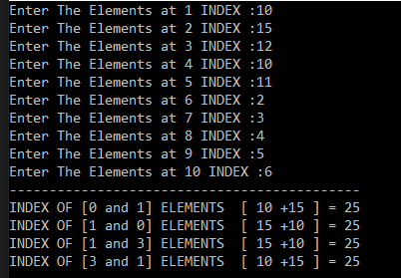

**2. Find the number of elements of A which are even, and the number of elements of A which are odd.**

**SOLUTION: OUTPUT:**

int i;

int[] num = new int[10];

int even=0, odd=0;

for (i = 0; i < num.Length; i++)

{

Console.Write("Enter Elemnts [{0}]:", i);

num[i] = int.Parse(Console.ReadLine());

if (num[i] % 2 == 0)

{

even += 1;

}

else

{

odd += 1;

}

}

Console.WriteLine("--------------------------");

Console.WriteLine("TOTAL EVEN IS :"+even);

Console.WriteLine("TOTAL ODD IS : "+odd);

Console.ReadLine();

**3:Write a procedure which finds the average of the value of A**

**SOLUTION:**

double sum = 0, avg;

int i;

int[] num = new int[10];

for (i = 0; i < num.Length; i++)

{

Console.Write("Enter Elemnts [{0}]:", i);

num[i] = int.Parse(Console.ReadLine());

sum += num[i];

}

avg = sum / 10;

Console.WriteLine("AVERAGE IS EQUAL TO :" + avg);

Console.ReadLine();

**OUTPUT:**

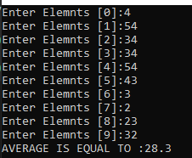

**2D ARRAYS**

**1. Write a program which input 2 matrix of user defined rows and columns and perform following operation**

**a. Display/Print as a Matrix**

**SOLUTION:**

int[,] num1 = new int[2, 2];

int[,] num2 = new int[2, 2];

int[,] num3 = new int[2, 2];

int i, j;

for ( i = 0; i < 2; i++)

{

for (j = 0; j <2; j++)

{

Console.Write("Enter NUMBER [{0},{1}] =",i,j);

num1[i, j] = int.Parse(Console.ReadLine());

}

}

for ( i = 0; i < 2; i++)

{

for ( j = 0; j < 2; j++)

{

Console.Write(num1[i, j]+" ");

}

Console.WriteLine();

}

Console.WriteLine("------------------------------");

for (i = 0; i < 2; i++)

{

for (j = 0; j < 2; j++)

{

Console.Write("Enter NUMBER [{0},{1}] =", i, j);

num1[i, j] = int.Parse(Console.ReadLine());

}

}

for (i = 0; i < 2; i++)

{

for (j = 0; j < 2; j++)

{

Console.Write(num1[i, j] + " ");

}

Console.WriteLine();

}

}

**OUTPUT:**

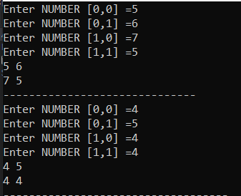

**b. Addition of Matrix**

**SOLUTION:**

int[,] num1 = new int[2, 2];

int[,] num2 = new int[2, 2];

int[,] num3 = new int[2, 2];

int i, j;

for ( i = 0; i < 2; i++)

{

for (j = 0; j <2; j++)

{

Console.Write("Enter NUMBER [{0},{1}] =",i,j);

num1[i, j] = int.Parse(Console.ReadLine());

}

}

for ( i = 0; i < 2; i++)

{

for ( j = 0; j < 2; j++)

{

Console.Write(num1[i, j]+" ");

}

Console.WriteLine();

}

Console.WriteLine("------------------------------");

for (i = 0; i < 2; i++)

{

for (j = 0; j < 2; j++)

{

Console.Write("Enter NUMBER [{0},{1}] =", i, j);

num1[i, j] = int.Parse(Console.ReadLine());

}

}

for (i = 0; i < 2; i++)

{

for (j = 0; j < 2; j++)

{

Console.Write(num1[i, j] + " ");

}

Console.WriteLine();

}

Console.WriteLine("-----------------------------------");

Console.WriteLine("SUM OF TWO MATRIX");

for (i = 0; i < 2; i++)

{

for (j = 0; j < 2; j++)

{

num3[i, j] = num1[i, j] + num2[i, j];

Console.Write(num3[i,j] + " ");

}

Console.WriteLine();

}

Console.ReadLine();

} }}

**OUTPUT:**

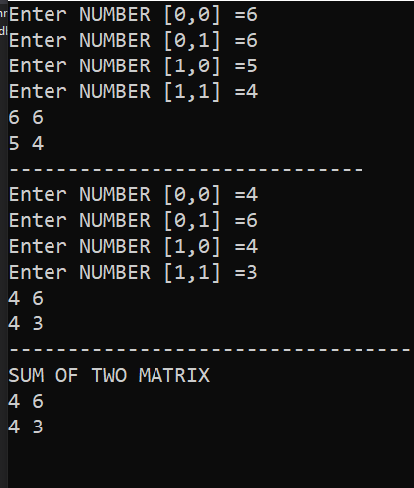

**c. Subtraction of Matrix**

**SOLUTION:**

int[,] num1 = new int[2, 2];

int[,] num2 = new int[2, 2];

int[,] num3 = new int[2, 2];

int i, j;

for ( i = 0; i < 2; i++)

{

for (j = 0; j <2; j++)

{

Console.Write("Enter NUMBER [{0},{1}] =",i,j);

num1[i, j] = int.Parse(Console.ReadLine());

} }

for ( i = 0; i < 2; i++)

{

for ( j = 0; j < 2; j++)

{

Console.Write(num1[i, j]+" ");

}

Console.WriteLine();

}

Console.WriteLine("------------------------------");

for (i = 0; i < 2; i++)

{

for (j = 0; j < 2; j++)

{

Console.Write("Enter NUMBER [{0},{1}] =", i, j);

num1[i, j] = int.Parse(Console.ReadLine());

}}

for (i = 0; i < 2; i++)

{

for (j = 0; j < 2; j++)

{

Console.Write(num1[i, j] + " ");

}

Console.WriteLine(); }

Console.WriteLine("-----------------------------------");

Console.WriteLine("SUM OF TWO MATRIX");

for (i = 0; i < 2; i++)

{

for (j = 0; j < 2; j++)

{

num3[i, j] = num1[i, j] - num2[i, j];

Console.Write(num3[i,j] + " ");

}

Console.WriteLine();

}

Console.ReadLine(); }

**OUTPUT:**

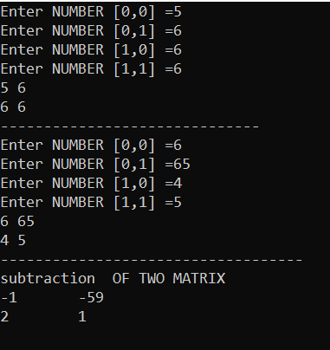

**d. matrix multiplication**

**SOLUTION:**

int i, j, k, r1, c1, r2, c2, sum = 0;

int[,] arr1 = new int[50, 50];

int[,] brr1 = new int[50, 50];

int[,] crr1 = new int[50, 50];

Console.Write("\n\nMultiplication of two Matrices\n");

Console.Write("----------------------------------\n");

Console.Write("\nInput the number of rows and columns of the first matrix :\n");

Console.Write("Rows : ");

r1 = Convert.ToInt32(Console.ReadLine());

Console.Write("Columns : ");

c1 = Convert.ToInt32(Console.ReadLine());

Console.Write("\nInput the number of rows of the second matrix :\n");

Console.Write("Rows : ");

r2 = Convert.ToInt32(Console.ReadLine());

Console.Write("Columns : ");

c2 = Convert.ToInt32(Console.ReadLine());

if (c1 != r2)

{

Console.Write("Mutiplication of Matrix is not possible.");

Console.Write("\nColumn of first matrix and row of second matrix must be same.");

}

else

{

Console.Write("Input elements in the first matrix :\n");

for (i = 0; i < r1; i++)

{

for (j = 0; j < c1; j++)

{

Console.Write("element - [{0}],[{1}] : ", i, j);

arr1[i, j] = Convert.ToInt32(Console.ReadLine());

}

}

Console.Write("Input elements in the second matrix :\n");

for (i = 0; i < r2; i++)

{

for (j = 0; j < c2; j++)

{

Console.Write("element - [{0}],[{1}] : ", i, j);

brr1[i, j] = Convert.ToInt32(Console.ReadLine());

}

}

Console.Write("\nThe First matrix is :\n");

for (i = 0; i < r1; i++)

{

Console.Write("\n");

for (j = 0; j < c1; j++)

Console.Write("{0}\t", arr1[i, j]);

}

Console.Write("\nThe Second matrix is :\n");

for (i = 0; i < r2; i++)

{

Console.Write("\n");

for (j = 0; j < c2; j++)

Console.Write("{0}\t", brr1[i, j]);

}

//multiplication of matrix

for (i = 0; i < r1; i++)

for (j = 0; j < c2; j++)

crr1[i, j] = 0;

for (i = 0; i < r1; i++) //row of first matrix

{

for (j = 0; j < c2; j++) //column of second matrix

{

sum = 0;

for (k = 0; k < c1; k++)

sum = sum + arr1[i, k] * brr1[k, j];

crr1[i, j] = sum;

}

}

Console.Write("\nThe multiplication of two matrix is : \n");

for (i = 0; i < r1; i++)

{

Console.Write("\n");

for (j = 0; j < c2; j++)

{

Console.Write("{0}\t", crr1[i, j]);

}

}

}

Console.Write("\n\n");

**OUTPUT:**

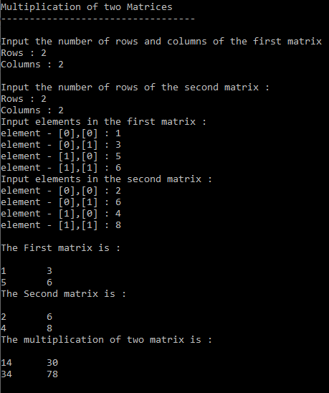

**e. Determinant**

**SOLUTION:**

int[,] a = new int[2, 2];

for (int i = 0; i < 2; i++)

{

for (int j = 0; j < 2; j++)

{

Console.Write("Enter THe Elements At [{0} ,{1}] Index :",i,j);

a[i, j] = int.Parse(Console.ReadLine());

}

}

int b=0;

for (int i = 0; i <1; i++)

{

for (int j = 0; j <1 ; j++)

{

b = a[i, j];

}

}

int c=0;

for (int i = 1; i < 2; i++)

{

for (int j = 1; j < 2; j++)

{

c = a[i, j];

}

}

for (int i = 0; i < 2; i++)

{

for (int j = 0; j < 2; j++)

{

Console.Write(a[i,j]+" ");

}

Console.Write("\n");

}

Console.WriteLine("------------------------------------");

int diagnoal = b * c;

Console.WriteLine("DIAGNOAL 1 IS EQUAL :"+diagnoal);

int e = 0;

for (int i = 0; i < 1; i++)

{

for (int j = 1; j < 2; j++)

{

e = a[i, j];

}

}

int f = 0;

for (int i = 1; i < 2; i++)

{

for (int j = 0; j < 1; j++)

{

f = a[i, j];

}

}

int diagonal2 = f * e;

Console.WriteLine("DIAGNOAL 2 IS EQUAL :" + diagonal2);

Console.WriteLine("-----------------------------------------");

int determinant = diagnoal - diagonal2;

Console.Write("DETERMINANT IS [{0} - {1}] = {2} ",diagnoal,diagonal2,determinant);

Console.ReadLine();

}

**OUTPUT:**

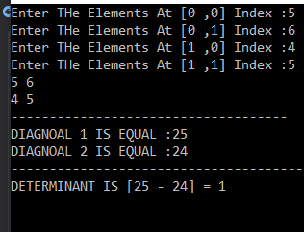

**f. Inverse**

**SOLUTION:**

double[,] matric1 = new double[2, 2];

for (int i = 0; i < matric1.GetLength(0); i++)

{

for (int j = 0; j < matric1.GetLength(1); j++)

{

Console.Write("enter the values of matrix [{0},{1}] : ", i, j);

matric1[i, j] = Convert.ToDouble(Console.ReadLine());

}

}

Console.WriteLine("\n");

for (int i = 0; i < matric1.GetLength(0); i++)

{

for (int j = 0; j < matric1.GetLength(1); j++)

{

Console.Write("" + matric1[i, j] + " ");

}

Console.WriteLine();

}

Console.WriteLine("=========INVERSE OF MATRIC======");

Console.WriteLine("\n");

double temp;

double[,] matric3 = new double[2, 2];

double ans = 0;

for (int i = 0; i < 2; i++)

{

for (int j = 0; j < 2; j++)

{

ans = matric1[0, 0] * matric1[1, 1] - matric1[0, 1] * matric1[1, 0];

}

}

for (int i = 0; i < 2; i++)

{

for (int j = 0; j < 2; j++)

{

temp = matric1[0, 0];

matric1[0, 0] = matric1[1, 1];

matric1[1, 1] = temp;

matric1[1, 0] = (-1) * (matric1[1, 0]);

Console.Write(" " + matric1[i, j] + " ");

matric1[0, 1] = (-1) * (matric1[0, 1]);

temp = matric1[0, 0];

matric1[0, 0] = matric1[1, 1];

matric1[1, 1] = temp;

}

Console.WriteLine();

}

try

{

for (int i = 0; i < 2; i++)

{

for (int j = 0; j < 2; j++)

{

if (i == 0 && j == 0)

{

matric3[0, 0] = matric1[0, 0] / ans;

}

else if (i == 1 && j == 0)

{

matric3[1, 0] = matric1[1, 0] / ans;

}

else if (i == 0 && j == 1)

{

matric3[0, 1] = matric1[0, 1] / ans;

}

else if (i == 1 && j == 1)

{

matric3[1, 1] = matric1[1, 1] / ans;

}

}

}

}

catch (Exception e)

{

Console.WriteLine(e.Message);

}

Console.WriteLine("RESULT OF DETERMINENT MATRICES");

Console.WriteLine("Determinent == {0} ", ans);

Console.WriteLine("\n");

Console.WriteLine("Inverse");

for (int i = 0; i < 2; i++)

{

for (int j = 0; j < 2; j++)

{

temp = matric3[0, 0];

matric3[0, 0] = matric3[1, 1];

matric3[1, 1] = temp;

matric3[1, 0] = (-1) * (matric3[1, 0]);

Console.Write(" " + matric3[i, j] + " ");

matric3[0, 1] = (-1) * (matric3[0, 1]);

temp = matric3[0, 0];

matric3[0, 0] = matric3[1, 1];

matric3[1, 1] = temp;

}

Console.WriteLine();

}

Console.WriteLine("\n");

Console.WriteLine("\n");

Console.ReadLine();

}

}

}

**OUTPUT:**

